Project overview
Prompt:
think like top 1% business analyst to identify common operational problems in insurance sales
identifying systemic operational failure points across the insurance sales lifecycle.

- High lead inflow, low qualified intent – So we have integrated Lead qualification into our system (Lead -> Prospect i.e qualified lead) -> This process reduces the sales team efforts on Dead leads, improving operational scope for qualified leads -> thereby increasing the probability of increasing revenue and then meeting targets. Decreases customer acquisition cost too -> because we are no more wasting our money and resources on dead leads.
  - A/B testing to understand if this was useful – Revenue - Cannibalization
- We map customer profile to Agent based on his / her product expertise – Sales cycle efficiency, drop off rate after first call i.e objection handling strength, Avg or Median premium per Policy, Policy wise conversion rate. All these mapped to Product Advisor Performance Matrix, say “Agent B converts high-income urban term leads best”.
Segment Intention type Product Best Advisor Conversion % Success Customer Language
Young[18-26] + Low Income[10K-35K] Investment Term Agent A 28% Telugu, English
Mid Age + Family Protection Health Agent C 22% Hindi, Urdu
Pre-retirement + Low Income Health
Based on Lead preferred language we assign Agent – to facilitate Customer comfort.
- Pivot these comma separated values.
AI looks for Product and Segment match with Lead profile, then we get a consolidated list of Agents. First preference is given to Language match and second would be to the Conversion rate.
- Once the awareness stage is completed for a Lead, based on Engagement pattern and conversion probability, follow-up process will pace up, in order to not lose the lead – they mostly enquire other policies too. So in our follow up process we ensure that the agent is constantly staying in touch with the lead, making them aware that our product is best in all terms against competitors – SLA enforcement or real time alerting. This improves conversion probability – say by 5-10% -> Reducing First Time Response Failure.
- Fake progress tracking – Agent says they are interested but sales didn’t increase ? Cannibalization Metrics – MQL SAL SQL
- Learning from Top customer instead of just holding to celebrations – Sales pitch improvements – Feedback loop
- Too much paperwork for Customer – making sure agent is all the way tied to Customer in order to make them comfortable with the process – reducing work on that day ? Analysing drop off rates at KYC, Documentation, Disclosures..
- Ignoring existing customers – UPSELLS -> Focussing on Renewal & Cross Sell Blindspots.
- Data accuracy – Schema enforcement through SQL

Prompt:
What are different types of risks surrounding my solution ? think like CEO and top 1% managerial cream
- Product Advisor matrix – if its formed on basis of past history then its misleading – It contains data where leads were given to agents and then performance was recorded, as part of strategy leads were given to agents. Say Product Advisor Performance matrix shows Agent A is best at converting low income urban leads – but Agent A was assigned with those leads as part of Strategy. He was never inherently best at them. So from now on, only this segment of leads come to Agent A & other agents are not preferred for this segment-> Self reinforcing loop. Agent B has now improved and he’s ready for mid risk leads after proper training. So the model must give mid risk leads to new trained agents in order to let them give performance check.
For this issue, lets consider taking Rolling performance as a metric rather than a quarter’s data. Here our decisions become accurate because we are assessing based on Consistency in performance over 4 quarters, not one quarter wonders.
Also we have to make sure that new trainees are given randomized lead every quarter to test their capability.
But why does our business have to lose those mid risk agents ? So we can assign these waiting period leads [Leads who have just completed their waiting period after Budget allocation or Stakeholder approval]

- Our whole concept around Lead qualification was to minimize efforts spent by agents, on dead leads.
Let us analyse the Lead cycle in our process.
Lead (raw inflow) → AI qualification → MQL (system-passed) → Agent acceptance decision → SAL → Agent engagement + BANT check → SQL → Needs analysis + proposal → Opportunity → Policy issued

Marketing Qualified Leads (MQLs) are prospects who've shown enough engagement with your marketing content to suggest genuine interest — they downloaded a brochure, filled a form, clicked an ad, or visited your pricing page multiple times. Marketing says "this person is worth talking to," but hasn't verified their actual intent or fit.
Sales Qualified Leads (SQLs) are prospects that the sales team has evaluated and confirmed are ready for a direct sales conversation — they have budget, authority to decide, a real need, and a defined timeline (the classic BANT framework).

A Marketing Qualified Lead(MQL) is LEAD
A Sales Qualified Lead(SQL) is PROSPECT (Lead succeeding in Lead Qualification)
The Sales Accepted Lead(SAL) ensures that teams don’t blame each other for not meeting targets. This stage creates a formal rejection mechanism with a reason code. That reason code is gold — it's the feedback loop your system currently lacks.
This forms Adaptive Lead Qualification loop.
- But what if Sales team comes up with useless reasons, just to overhead marketing team ? Hence we introduce SAL criteria.
• Lead has expressed a specific product interest (not just "insurance")
• Income band is captured and within product eligibility range
• Phone number is valid and reachable
• Lead is within a serviceable geography
If those four are met, the agent must accept it. No discretion. Rejection is only allowed with a logged reason code.
Build rejection reason codes When an agent rejects an SAL, they must pick from a defined list — not free text. Something like:
- Duplicate lead
- Unreachable after 3 attempts
- Income ineligible for product
- Already a customer
- Clearly not interested / wrong person
But what is the guarantee that user gives correct salary – trust issues - why are we even tracking down income right here
Script:
At the agent call — the real verification moment The agent conversation is actually your most reliable income signal if structured correctly. Train agents to ask:
- "Are you currently salaried or running a business?"
- "Is this for a company-provided policy or personal?"
- "What premium range were you thinking?"
The answer to that last question is the most honest income signal you'll ever get. Nobody says ₹80,000 annual premium if they're earning ₹2 lakh a year.

ARCHITECTURE
Prompt : Think like top 1% data security architect in the world to Categorize data into sensitivity levels, based on which suggest architecture involving all features recommended in the pasted matter. consider last 5 years advanced data crimes & thereby design architecture. note that these table structures are not fixed - they can be changed but storing all this cols info is mandatory
Now I have a complete picture. Let me build a world-class data architecture sensitivity map.Now let me build this comprehensive architecture map:Here's the full architectural rationale as a top 1% data architect would frame it.
We can decide where to store the data based on these conditions :
- Sensitivity – how risky it is when this data gets exposed.
- Compliance – Data governance / Regulations imposed by Govt on data usage and storage.
- Query Pattern – Exploration [ Cohort Analysis / Segmentation / Trend exploration / Feature extraction] or just displaying values on Dashboard. For displaying values, aggregation table is enough. But for analysis we need Lakehouse / Databricks. We cant do analysis directly on SQL server because it stores raw PHI – which is not compliant under HIPAA or DPDP or GDPR.
- Performance – How fast should reports run – If repeated computations are there and we need to increase speed, we go for Aggregation table.
- Business usecase – Is this data useful for Analytics or just for Operational support [OLTP vs OLAP]
- Re-identification risk – If this data or column could be used in joins in order to identify PHI or PII(Personally Identifiable Information)
- Granularity – OLS/RLS/T-SQL
Aggregation table – Gold layer in Medallion Architecture using Databricks or Dataflow in Power BI. If the logic is just business team level or just one Dashboard level & not suitable for Enterprise level use, then go for Dataflow. If you want Enterprise level(Multiple teams – Risk Management team, Finance team, Sales Team, Marketing team) to use the same logic – Create aggregation table in Gold layer of Databricks – this comes with strict governance unlike Power BI.
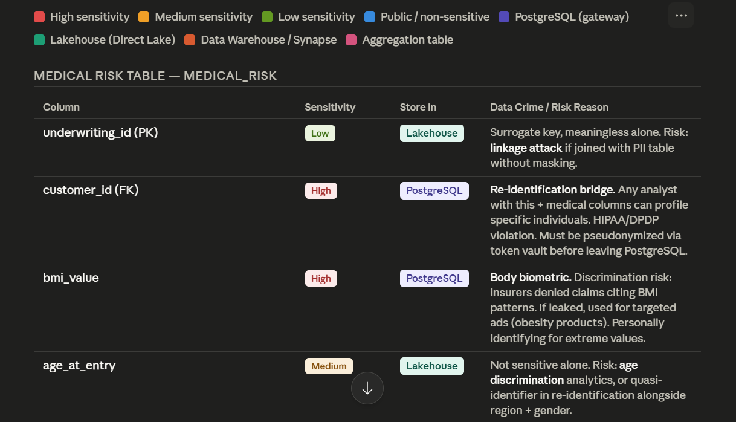

Underwriting_id is just a surrogate key but when combined with other data – there is chance of Linkage attack(Happens when two safely looking datasets get combined, which reveals a person identification or sensitive medical data) – Hence it is sensitive – but low.
Here we are pseudonymizing customer id, to avoid re-identification attack , linking with other databases and then querying based on customer id - this is a threat as HIPAA(US policy rule – Health Insurance Portability and Accountability Act), DPDP(India policy rule – Digital Personal Data Protection), GDPR(EU policy rule – General Data Protection Regulation). Only secure vault knows mapping to that Pseudonymized data. This data could be dealt by Analysts which is a threat to patient info. This is highly sensitive column – Hence it has to be stored in PostGRE SQL.
There could be extreme cases of BMI – which can reveal patient identity -> this is called Quasi-identifier risk. Hence BMI is also considered to be Highly sensitive – because this is Health Biometric.
Age_at_entry -> This data is widely used in Dashboards, Segmentation, ML models and Actuarial Analytics(Pricing, Reserves for Future, Risk Assessment). But age becomes sensitive when combined with disease, location and gender – say 92 year male in a small village, this makes the person likely identifiable – Hence this column is moderately sensitive – To be stored in Lakehouse, to be easily accessible for Dashboard and Analytics. Anyway this is going to be strictly secured with RLS, OLS.

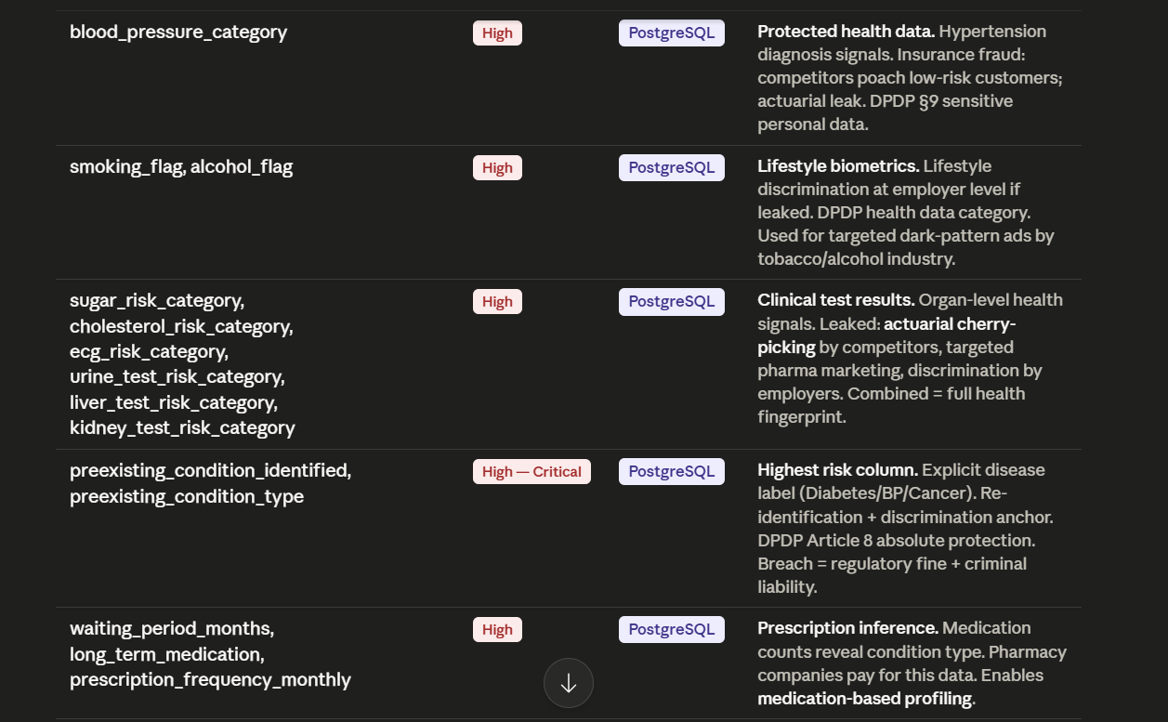

All this is PHI(Protected Health Information) – Hence it has to be stored in PostGRE SQL Server due to its high sensitivity.
Smoking and Alcohol status along with other indicators – allow to infer Lead’s quality of life, addiction patterns – These are called Lifestyle biometrics and these could be a threat if used for Dark advertising.
These details form Full Heath Fingerprint – Competitors could cherrypick healthy leads to offer Insurance premiums at Competitive pricing – This is called Actuarial Leak.
This information could serve as a Reidentification anchor – say rare disease +bmi +age or some weird filter like this.
This data has to be secured from Pharma companies – to avoid targeted marketing through medication based profiling to lifetime medicine needs based on Prescription Inference.

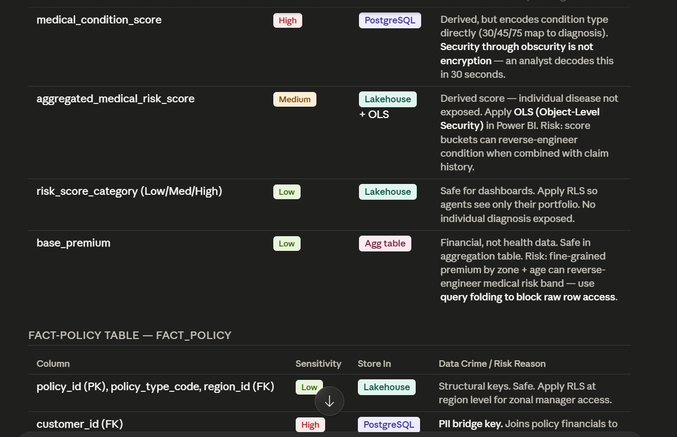
This is:
Sensitivity Reduction Architecture
Meaning:
Transform highly sensitive health data into safer analytical representations. Like Instead of exposing raw PHI , we are converting it to medical condition score, and then into aggregated medical risk score - which is then exposed to Lakehouse – applied OLS and then exposed to Dashboards.
Here medical condition score can be easily inferred by data analysts – Hence this medical condition scores are stored in PostGRE SQL , aggregated are exposed to Lakehouse.
Sensitivity through Obscurity is not Encryption -> Obscurity means hiding . This means hiding some data doesn’t mean encryption. Because even aggregated medical risk score can be compared with claim type history of patients to understand PHI. Hence we are using only risk_score_category in dashboards – Low / Moderate / High -> This is Business safe abstraction. For this Lakehouse is enough.
OLS – Which columns / tables are visible
RLS – which rows are visible
Base premium – How to use Query folding to block raw data access ?
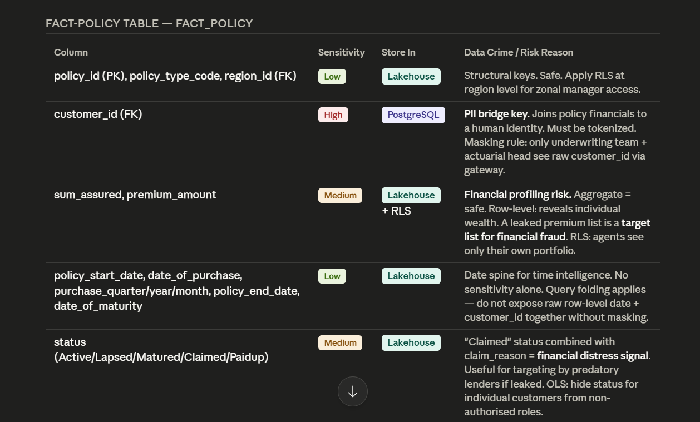

For policy_id, policy_type_code and region_id apply RLS, so that Regional managers can only see their region respective data.
Customer_id is highly sensitive and it exists in Policy table, claims table, medical risk table - It is an Identity connector – Hence company must prevent unrestricted joins that combine business analytics data with PHI and PII – Data Policies at Admin level and Fabric settings ?
Only underwriting team and Actuarial analysts can see raw IDs – RLS
Agents must be able to see sum_assured and premium_amount of their customers only – RLS – Customers / Leads ? This prevents unauthorized Sales targeting.
Dates + premium + customer_id -> Behavior profiling -> Query folding
Policy status claimed + claim reason could reveal financial distress, death or illness -> competitors target vulnerable customers -> hence apply ols for claim history

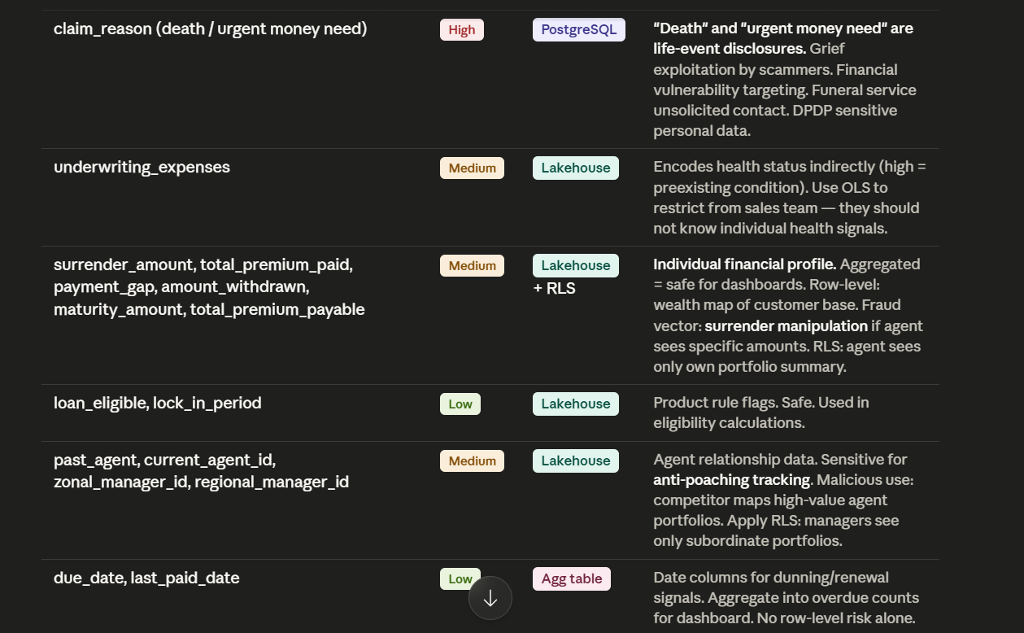

Claim reason might reveal vulnerability. Targeting them because of Financial distress.
Underwriting expenses – Very high underwriting expenses reveal the risk level of Lead. This is Indirect Health decoding. Sales team should not see health severity - OLS.
Agents shouldn’t see Financial measures like surrender_amount, total_premium_paid, total_premium_payable which reveal the Customer Financial health – RLS – To be stored in Lakehouse
Loan_eligible -> low sensitivity -> Lakehouse
Agent_id, regionalmanager_id, zonalmanager_id -> This combination reveals Relationship Intelligence. This info can be used in reidentifying ultra networth clients -> Competitors may try recruiting this agent to get those customers. Therefore Managers should only see their suboardinate agents not entire network of agents - RLS

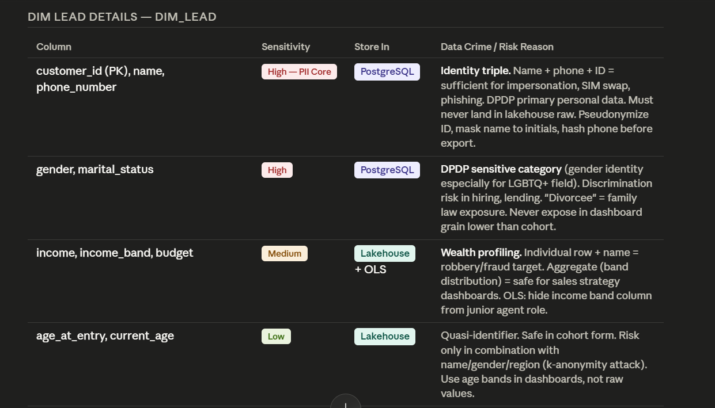
customer_id + name + phone -> this is high PII core. Data crimes around this are SIM swap fraud, Impersonation, phishing. Hence these details must be pseudonymized before being sent into Lakehouse -> Phone number hashed, Customer ID tokenized. Name ?
gender +marital status -> highly sensitive, when it could be used to target divorcee women.. So disable Individual statuses for these columns -> have age gender groups. Don’t scrutinize deeper analytics for these columns.
Income + budget -> This is Socio economic Intelligence -> Wealth targeting risk.
Occupation -> medium sensitive because it becomes quasi identifier -> cardiac surgeon in small city is easy to identify PII.
Never expose raw_occupation + name -> linkability prevention

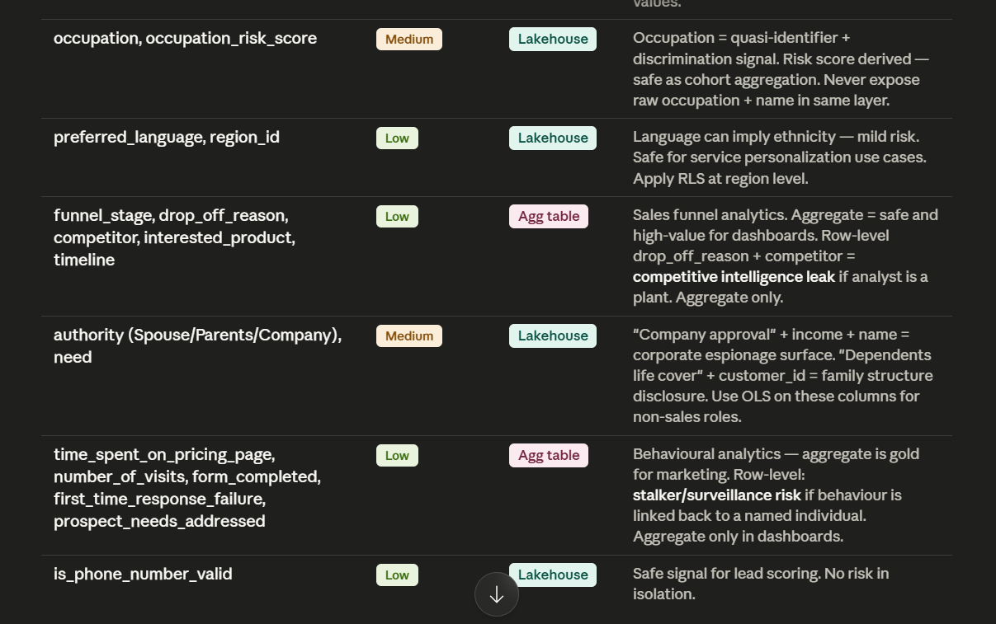
Funnel_stage, drop_off_reason -> Aggregation table. This becomes Competitive intelligence because Competitor could learn dissatisfaction or drop off reasons of our product. That is why we have RLS,OLS
Based on this phone number valid flag, what if list is sent out to competitors ? FABRIC set to not export data by agents or any

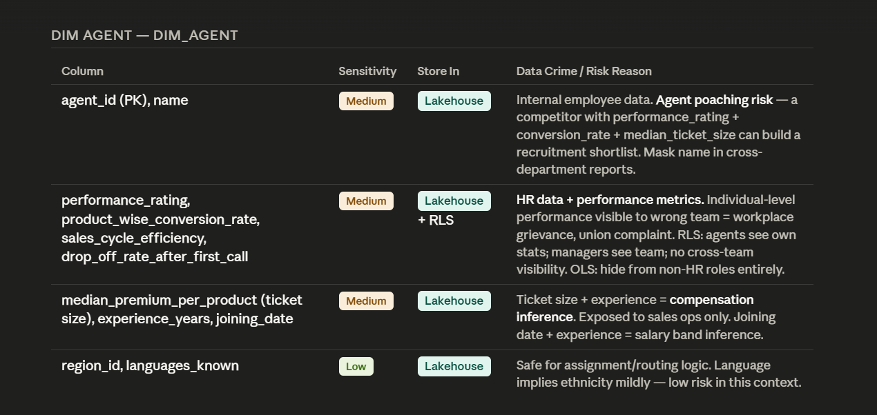
Agent_id and name are mediumly sensitive because Competitors could identify company’s talent based on avg ticket and other factors – top performers to poach.
Performance rating could leave a scope for internal politics. Hence agent should always be able to see only his rating , manager should be able to see only his subordinates ratings.. This is called hierarchy aware governance.
Median_premium_per_product -> this could be indirect payroll inference.
joining_date + experience_years -> promotions stage, retention risk.

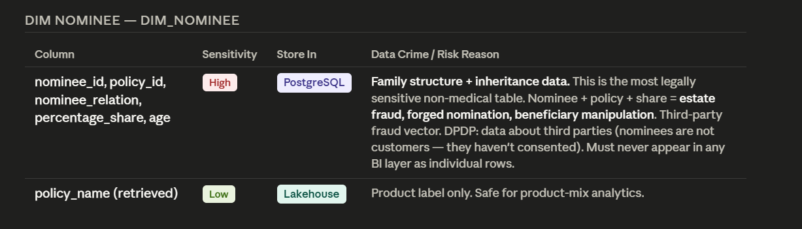
Nominee details could reveal marital status, inheritance ownership, family dependents -> This is called Inheritance Intelligence. Hence this is highly risk -> forged nomination risk, beneficiary manipulation risk. Therefore this data must never appear in BI as individual rows.

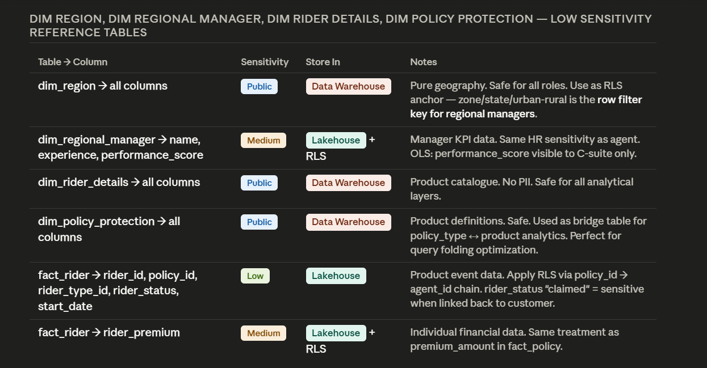

The governing principle: data sensitivity is not about the column in isolation — it's about what that column enables when joined.
A customer_id seems like an innocuous foreign key. But in an insurance schema it's a re-identification master key — the moment it appears alongside preexisting_condition_type, you have a named individual with a cancer diagnosis. That's a DPDP Article 8 criminal liability, not just a GDPR fine. This is why customer_id lives only in PostgreSQL behind a gateway, and every analytical layer receives a pseudonymized token instead.

The three data crime patterns to architect against:
1. Re-identification attack. Quasi-identifiers like age + gender + region + occupation can uniquely identify a person in a dataset of millions — this is the Latanya Sweeney finding that shook US healthcare. Your schema has this attack surface in dim_lead. The mitigation: age bands instead of raw values, never expose gender + region + income in the same query grain below district level.
2. Inference attack. medical_condition_score stores 30 for Diabetes, 45 for BP, 75 for Cancer. A junior analyst decodes this mapping in one SELECT DISTINCT. underwriting_expenses encodes health status as "high/medium/low." These derived columns look safe but are just lightly obfuscated diagnoses. They need the same PostgreSQL treatment as the raw fields.
3. Linkage attack via the fact table. fact_policy joins to medical_risk on customer_id and joins to dim_lead (which has name + phone). Without tokenization this creates a single query path from a policy claim reason ("death") all the way to a named person's phone number and clinical test results. The bridge table pattern you want for Power BI must be built with tokenized IDs only — the raw join must be gated behind the PostgreSQL gateway.

On dim_nominee specifically — the most underrated sensitive table: nominees are third parties who have never consented to data processing. They're not your customers. DPDP 2023 requires explicit consent from data subjects — you cannot store a nominee's age, relation, and inheritance share in a lakehouse accessible to sales dashboards. This table must be PostgreSQL-only, query-gated, with access limited to actuarial and claims teams only.

RLS + OLS enforcement architecture in brief:
- RLS anchor: region_id in dim_region → zonal managers see only their zone's policies, agents see only their own portfolio
- OLS: hide income, underwriting_expenses, authority, performance_rating columns entirely from junior analyst roles in the semantic model
- T-SQL views in Synapse expose pre-filtered aggregations that never contain customer_id or clinical fields — query folding ensures Power BI pushes predicates down before any row is transmitted
Want me to now tackle Part 2 (dirty dataset + advanced SQL cleaning queries) or Part 3 (OKR-based ₹15M sales strategy) next?

Roles I am dealing with in this Project
This project highlights operational issues in Insurance domain and a solution around it – So it is not some random project, we are using Current usecase in Industry – Business Analyst - Would be great with documentation done properly on Miro, Notion & Jira.
- Fixed Lead-to-Advisor logic
- Lead Inflow Management
- SLA enforcement
- Advisor Productivity Balance
- Focus on Renewal & Cross sell blind spots

Building Medallion Architecture – Aggregation table in Gold layer of Databricks. ADF for Data ingestion into Lakehouse – Data Engineer or Analytical Engineer.
This project is not just into Leads tracking and their conversion rate – CRM Analyst, but not D365 Sales Analyst because we didn’t use D365 CRM.
We have scrutinized Sales funnel – Sales Analyst
We are tracking the lead via UTM parameters – UX Analyst. Our funnel consists of scrutinized areas like Page Drop off rate, Time spent on pricing page…. We are involving GA4 here to understand Attribution clarity – Marketing Analyst
Here we are dealing with Cannibalization, Guard rail metrics, A/B Testing – this takes me to Product Analyst
Operations Monitoring & Data accuracy through Validation pipelines
We are executing all this on PostGRE SQL and Fabric – Fabric Developer, SQL BI Developer
Here we are suggesting the Strategy for Sales – Data Storytelling, Strategist. KPIs based on OKR templates to track Strategy Implementation.
- Incentive alignment
- Product Advisor Performance Matrix
- Lead Alignment
- Revenue Layer (Primary)
- Best leads → top agents
👉 Maximize conversions
- Learning Layer (Secondary)
- Some good leads with mid risk → mid agents
👉 Improve them with feedback
- Training Layer
- Fresh/weak performance agents:
  - Shadow top agents
  - Handle warm but not premium leads, low risk leads

Automated Audit Reports, SSRS reports – Audit Analyst
I am turning into a person with these many cross functional areas of Knowledge – We are highly eligible to Sales Manager role and then this could be the better way to explain my knowledge over Business Implementation in IBM interview.
What is the proper way of capturing Executives attention through my Presentation – that tells that I am cross functionally fit.

Challenges
- We don’t just have Lead qualification based on Static rules. We have an ADAPTIVE LEAD QUALIFICATION SYSTEM that updates itself (Azure DevOps) based on Cohort analysis and real time conversion patterns. Eliminates bias (e.g., assuming high income = high conversion)
Inputs (features)
- Demographics (age, income, city)
- Behavioural:
  - Time spent on pricing page
  - Number of visits rate
  - Form completion drop-offs
- Channel source (Google, agent referral, aggregator)
- Time of inquiry
- Product interest (term, health, ULIP)
  - This system doesn’t just updates Lead quality to system – before that it undergoes Bias corrected learning (Is this lead quality impact or Agent performance impact) -> We can isolate this using Attribution split , which is a Structural Causal Model.
for each low-quality lead that converted, find a comparable lead (same score, same features) that was handled by an average agent. If that comparable lead did NOT convert, the conversion was agent-driven, not lead-driven.
UNDERSTOOD TO FREEZE EXPECTATIONS – AGILE LEARNING.

Interview attitude

Enterprise Insurance Analytics Platform with Governance, Security, Semantic Optimization, and Regulatory Intelligence

Top 1% Analyst Thinking
Elite insurance analysts always ask: “Can this field identify a person when combined with another field?”

- Make it Funnel wise - for this job, let us assume 100% people have applied. but out of them only 75% people appear confident with aesthetic dashboard in application and resume - thinking this will make them stand apart. Dragging and dropping visuals onto Dashboard is just a cakewalk - but actual story that data is telling, has to be interpreted without any guesses - because businesses work on data not gut feeelings. out of those 75% , 50% fail to tell a story. Of ones which make an attempt to tell a story, kpi design doesn't work. they think metric itself is a kpi. But i design kpis with okr(objectives key results framework) template, so that kpis are not just designed for dashboard purpose, they are also useful in tracking down the implementation of proposed strategy under given timelines, in order to reach our target.

- Didn't just blindly build systems - followed HIPAA, IRDA, PDPB protocols - analyzing last few years data crimes – Followed Regulatory Isolation Architecture - Sensitive regulated data is isolated into protected layers so it cannot freely move across systems.

Top 1% Data Governance Thinking
Elite companies assume:
“Any dataset can become dangerous when joined.”
That is why:
- tokenization exists
- RBAC exists
- masking exists
- secure layers exist

How to handle records with bad data or missing values
- Add data_quality_flag as a column in database , mark records with bad data or missing values as Invalid
- Now send them back to source for Data quality verification and Error handling. We are handling at root level.
- Delete duplicate records only after approval of Governance / Compliance team – This makes sure that audit reports are transparent and regulations are followed without skipping. Also we are not erasing traceability of record unneccesarily.
Sensitivity through obscurity is not Encryption – Hence we aggregate, tokenize and then use in Dashboards
Raw Medical Data → Derived Risk Intelligence → Safe Business Analytics
Contextual Sensitivity Modeling – I am doing this kind of politics to avoid internal politics and Competitive intelligence leak.
This project is an ideal proof of Multilevel governance – because design is being done around Competitive Intelligence, Workforce Intelligence and other Intelligence aspect based risks.

Data mining like a Pro
I haven’t drove my work right away to analysis with some basic cleaning , I have reconciliated the data quality and then designed a system to prevent recurrence, then I have designed KPIs based on OKRs . Then went on to Dashboard storytelling.
Data cleaning like a Pro

First question - Data size - If its millions of records - Doing datamining on Excel is futile - So we can go for options like SQL, Pyrhon or advanced options like Power Query.

Then lets start the actual process with
1. Data Profiling
Which means I would get the data profile of each column - null distributions, duplicate percentages, schema mismatches, abnormal distribution like Outliers, datatype violations, timestamp inconsistencies ( date of purchase > polich anniversary).
Understand the nature of these errors - whether is from source, operational failures like sync failure or systemic failure like encryption failures..

2. Standardization
Standardize ap, a.p and andhrapradesh to AP. We can do this by mapping all the data to a Master standardized reference table.
Use Power Query to transform at this level say million of records.
We have to standardize categorical values, date formats, phone numbers - with country code or not, naming conventions

3. Validation rules
Uniqueness constraints - without this dashboards inflate numbers. Ops teams would contact same team twice.
Mandatory fields check - if these fields are not there in record - it is not worthy to perform next operations. Revert these records to source.
Regex validation - Regular expressions check whether data follows regular format or not. Phone number - ^[0-9]{10}$. Email ^[A-Za-z0-9._%+-]+@[A-Za-z0-9.-]+\.[A-Za-z]{2,}$
Pan card [A-Z]{5}[0-9]{4}[A-Z]{1}
Referential Integrity - record references to a record in other table. But pointing revord never exists.
Timestamp sequencing - date of purchase > policy anniversary
Cross table reconcilation - missing transactions, currency conversion issues,delayed ingestion, failed joins.

4. Reconcilation strategy - Verifying that data has moved correctly from source to our target reporting systems - without any data loss, corruption, duplication or transformation errors.
Row count check - Some records might have missed during Ingestion - Filter may be applied wrongly, ETL might have failed..
To do this, in SQL we use COUNT(*)
In Power query we can check row count
Compare totals - row count is same , but kpi is different - may be due to duplicate removal, currency conversion issues, failed joins, missing transactions.
SUM(revenue)
COUNT(customers)
AVG(order value)
MAX(timestamp)
MIN(timestamp)
Hash reconciliation - Hash is a unique fingerprint generated for each record based on its row values. Even if one character changes , a different hash gets created - This makes it easy for us to identify corrupted records/ altered records / transformation issues.
Source-to-Target mapping - Sometimes, wrong column is mapped between source and target, sometimes there could be datatype mismatch, sometimes transformation logic might have been broken.
Based on all these reconciliation checks, we classify discrepancies
Acceptable variance - timestamp delays, rounding differences, streaming latency (latency between record being created in source system and record being displayed or updated on Dashboard).
Recoverable issues - Partial sync failure, null timestamps, duplicate records
Critical Integrity failures - Deleted records, customer identity mismatches, broken joins, compliance data corruption, financial totals incorrect - Dashboard must have all these issues reported, with evidence. In these cases, stop reporting, escalate the issue immediately, initiate root cause analysis.

5. Handling missing values
If field is critical - financial amounts, compliance fields, customer identity -> then escalate the record back to source system.
Else, we can use descriptive measures of Statistics to impute.

6. Preventing Recurrence
Automated Anomaly alerts - Data activator
Schema enforcement
Observability dashboards - Reconciliation work
Deduplication logic - A set of rules used to identify, merge, remove or prioritize duplicate records in a dataset.
Say, names and ids differ - but same phone number - which means same person gets calls twice - dashboards inflate lead count, conversion rates become wrong, marketing spend increases.
Exact deduplication - records are duplicate only when values match exactly - say 4564 and 4564 are duplicate. For this SQL logic is GROUP BY Number HAVING COUNT(*)>1;
Fuzzy matching logic - Because real world data is messy.
Fuzzy matching uses - similarity score, phonetics, edit distance and pattern matching.
Rule based Deduplication - If phone number and pincode matches - then its duplicate.
Survivorship logic - After identifying duplicates, which record should survive ? latest timestamp, more non-null fields, verified status, highest source priority.
Identify and Classify these types of duplicate records, merge them , Preserve audit trial, merge history and timestamps, source lineage.

Datawarehouse – Structured data storage – advanced SQL queries – expensive – Schema on write – designed for BI reporting
Data lake – like Azure Data lake – for storing all types of data – It’s a staging area, on which we can perform analysis rather than directly on raw pii, phi sources – limited sql support, dependent on engine – cheap – Schema on read – ML Support and Streaming data
Data Lakehouse – like Delta lake – combines both the capabilities of Data lake and Datawarehouse – Its got a transactional layer supporting ACID operations, just like SQL.

Credentials
Data directory - C:\Program Files\PostgreSQL\18\data
Password – Insured@123
Port – 5432Installation Directory: C:\Program Files\PostgreSQL\18
Server Installation Directory: C:\Program Files\PostgreSQL\18
Data Directory: C:\Program Files\PostgreSQL\18\data
Database Port: 5432
Database Superuser: postgres
Operating System Account: NT AUTHORITY\NetworkService
Database Service: postgresql-x64-18
Command Line Tools Installation Directory: C:\Program Files\PostgreSQL\18
pgAdmin4 Installation Directory: C:\Program Files\PostgreSQL\18\pgAdmin 4
Stack Builder Installation Directory: C:\Program Files\PostgreSQL\18
Installation Log: C:\Users\GS\AppData\Local\Temp\install-postgresql.log
Locale – default

